**Take Home Program #8 – Due on or before Tuesday 4/30, 2019 –**

**Objectives:** Single Dimensional Array

Your name:

|  |
| --- |
| **Important instructions:**   * *All programs must include comments at the top of your program: your name,* the class name (CSIT 575)*, program name and* ***the program description (purpose of the program).*** * *Copy and paste your* ***program code*** *and* ***output*** *in Part B of each program. Note: Use snipping tool to* ***snip the output****.* * *Once it is done, save and submit this word file via Canvas.* |

**FindLargestScore.cpp**

Write a program that reads in 5 scores and only accepts score in the range from 1 to 100. Once all is valid; display all scores, find the highest score and shows how much each score differs from the highest score.

**Sample run:**

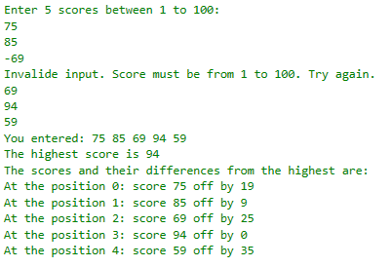

**Part B: Copy and paste your program (source) code and the outputs after this line**

**+++++++++++++++++++++++++++++++++++++++++++++++++**